Pacific Area Long-term Atmospheric observation for the Understanding of climate change
(PALAU) project

Ryuichi SHIROOKA
Frontier Observational Research System for Global Change (FORSGC)
Climate Variations Observational Research Program
Air-Sea Interaction in the Western Pacific Ocean Group /
Hydrological Cycle Observational Research Program
Cloud and Precipitation Processes Group

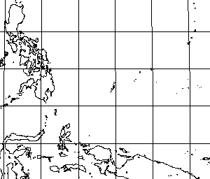
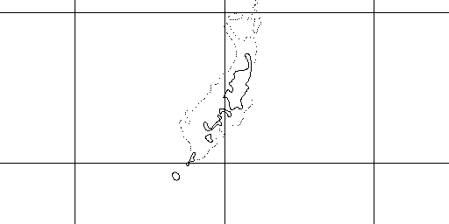
Radiosonde launching from Koror ◎
AWS, PRP, GPS, TSI, CEIL, and MWR site on Peleliu ★
Guam
Palau
☆MIRAI
10°N
Eq.
140°E
130°E

134ﾟ30'E
7ﾟN
8ﾟN
Koror
Peleliu

PALAU (Pacific Area Long-term Atmospheric observation for the Understanding of climate change) project
FORSCG (CVORP air-sea interactions / HCORP clouds-precipitation processes)
 |  | Y2000 |  | Y2001 |  | Y2002 |  | Y2003 |  | Y2004
 |  |  | FY2000 |  | FY2001 |  | FY2002 |  | FY2003 |  | FY2004
Main target |  | Preliminary obs. Water vapor transport Convective cloud Cloud microphysics  To catch the El Niño signal  （to elucidate the structure of El Niño）
 | ＡＷＳ  ＰＲＰ  ＧＰＳ  ＣＥＩＬ  ＴＳＩ  ＭＷＲ  Windprofiler  Doppler radar | Long-term observations  To catch the structure of  MJO to ENSO time scale
IOP | Aerosonde  Airplane  (Drop sonde)  (Cloud radar/Lidar)  Radio sonde  Disdrometer  Transportableradar  (Cloud radar)  (X-band radar)  R/V Mirai | Multi-scale interaction  Process study  Cloud convections  Cloud cluster  Super cloud cluster

PALAU: Peleliu Island site (7.05 N, 134.27 E)

AWS (Automatic Weather Station):
air temperature, humidity, pressure, rainfall amount and rate, wind speed and direction.
every one minute

PRP (Portable Radiation Package):
long-wave and short-wave downward radiation
every one minute

GPS (Global Positioning System):
accumulated precipitable water
every 5 or 30 minute

CEIL(Ceilometer):
cloud base height
every one minute

TSI (Total Sky Imager):
cloud amount
every one minute (in daytime)

MWR (Microwave Radiometer):
temperature and humidity profile, precipitable water, liquid water content
every 15 minute

