Comparing the diurnal behaviour of MOLTS model output with CEOP in-situ data
Dr Lawrie Rikus
Bureau of Meteorology Research Centre, Melbourne, Vic, 3001, AUSTRALIA
Introduction

The Coordinated Enhanced Observing Period (CEOP) is an element of the World Climate Research programme initiated by the Global Energy and Water Cycle Experiment. For this presentation the NWP model data considered is the time series of model variables (MOLTS) at the locations of a number of in-situ data sites. MOLTS are available for a number of modelling centres at 3 hourly time resolution and come in two 'flavours'; a time series from the continuous assimilation cycle and various forecast series generated by concatenating 24 hourly segments of daily model forecasts. In previous studies (Rikus 2007) we have examined the MOLTS from the BMRC model which has an hourly time resolution. This study is an extension to more models and more in-situ sites although only results from the BMRC MOLTS at the Murray-Darling Basin (MDB) (Siriwardena et al 2003) site are shown in this abstract.

Diurnal behaviour from time binning

The simplest way to analyse the diurnal part of a time series is to sort the series into daily time bins representing the diurnal cycle. This assumes that the non-diurnal behaviour is random and that the diurnal behaviour itself is invariant over the total time of the series; an assumption that is certainly not correct for annual series of variables where seasons play an important role. The binning technique is also sensitive to the presence of model spin-up; since the forecasts are explicitly 'tied' to the analysis series every 6 hours a saw tooth pattern can be induced which can add harmonics that confuse the interpretation.
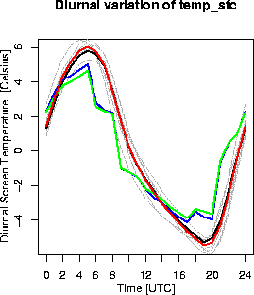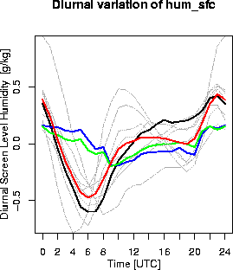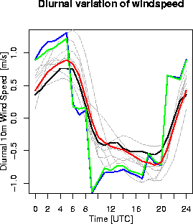

Figure 1: The diurnal variation (relative to each mean) of screen level temperature (left) and specific humidity (centre) and 10m wind speed (right) for the stations in the Murray Darling Basin. The different MDB sites are plotted in grey with Kyeamba (the site closest to the BMRC model's MOLTS point in black. The mean MDB results are in red and the model is green (the analysis cycle) and blue (the 12-36 hour forecast cycle).
Figure 1 shows the mean diurnal variation of screen level temperature and specific humidity and 10m wind speed for the MDB. The model results show distinct discontinuities due to a combination of assimilation 'shocks' (where the model is corrected at the end of each 6 hour cycle by the analysis in the assimilation cycle), the effects of model spin-up in the concatenation of separate forecast segments and the effect of a 3 hour radiation time step. The latter introduces a lag in the radiation which is responsible for the phase error in the temperature. The model largely misses the diurnal structure of the screen level specific humidity but (apart from the obvious discontinuities and phase lag consistent with that for temperature) gives a fair representation of the variation in wind speed.

Application of wavelet techniques

A more sophisticated way to investigate the variation of the diurnal cycle of a time series is to perform a wavelet analysis and filter out the non-diurnal time scales. Using
statistical significance tests (Torrence and Compo 1998) the time periods when diurnal power is strong can be isolated and studied in more detail. The relevant time series are shown in Figure 2. All variables show decreased diurnal power over the period of 150 to 330 days which corresponds to winter. The temperature exhibits most power over the year although the humidity shows significant power only over the summer months. For both screen variables the model has less power than any of the stations for a large proportion of the time. For wind speed, however, the model is higher than some of the stations and usually comparable with the mean dataset. This is confirmed by the relative magnitudes of the global wavelet power spectrum peaks shown in Figure 3 which also shows that the model is in much better agreement with the Kyeamba data than the mean MDB data for wind speed but the reverse is true for screen level specific humidity. Note that there were no peaks at longer periods which were statistically significant.
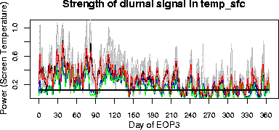
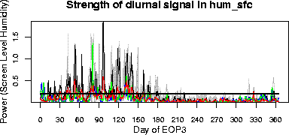
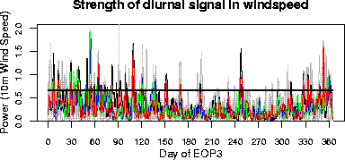

Figure 2. Time series of the power in the diurnal frequencies for screen level temperature (top) and specific humidity (center) and 10m wind speed (bottom) for the MDB and the BMRC model. The thick horizontal black line is the maximum of the 95% significance levels of all time series. All other lines are as for Figure 1.

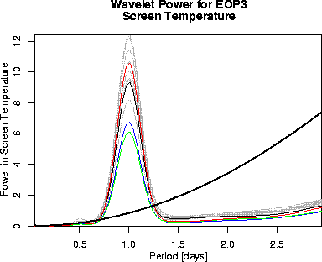
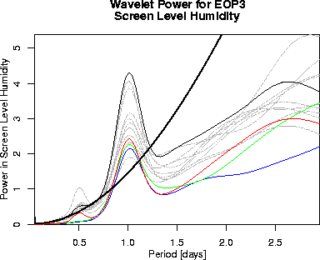
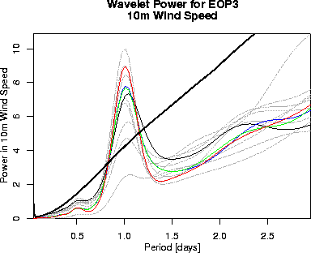

Figure 3. The wavelet power spectra of screen temperature (left) and specific humidity (centre) and 10m wind speed (right) in the diurnal spectral region. The solid black line is the maximum of the 95% significance levels of all time series. All other lines are as for Figure 2.

References

Rikus, L., 2007: A comparison of some surface variables in the BMRC MOLTS with CEOP in-situ data for EOP3. To be published in the Special CEOP issue of the Journal of the Meteorological Society of Japan.
Siriwardena, L., Chiew, F., Richter, H. and Western, A., 2003: Preparation of a climate data set for the Murrumbidgee River Catchment for land surface modelling experiments. Cooperative Research Centre for Catchment Hydrology working document 03/1, Cooperative Research Centre for Catchment Hydrology, Clayton, Victoria, Australia.
Torrence, C. and Compo, G.P. 1998: A Practical Guide to Wavelet Analysis. Bull. Amer. Meteor. Soc., 79, 61-78.

